JK BRIVA – BIOGRAD NA MORU 11.03. – 13.03.2022.
SAILING INSTRUCTIONS
PRVA BRIVA
Optimist

Abbreviations
[SP] denotes a rule for which a standard penalty may be applied by the race committee without a hearing. This changes RRS 60.1, 63.1 and Appendix A5.
[DP] denotes a rule for which the penalty is at the discretion of the Jury.
[NP] denotes that a breach of this rule will not be grounds for a protest by a boat. This changes RRS 60.1(a).

1 | Rules  1.1. The Race shall be governed by the rules as defined in the Racing Rules of Sailing.  1.2. The first three sentences of RRS 61.1(a) are changed to ‘A boat intending to protest shall inform the other boat at the first reasonable opportunity. When her protest will concern an incident in the racing area that she was involved in or saw she shall hail ‘Protest’. She shall inform the Race Committee at the finishing line immediately after finishing of the boat/s being protested in the manner described in SI 17.1, or as soon as practicable after she retires.’  1.3. Croatian shall be the official language of the event.  1.4. If there is conflict between the NoR and the SIs, then the SIs shall prevail. This changes RRS 63.7.
2 | Notices to Competitors  All notices to competitors will be posted on the official noticeboard on the event website www.jk-briva.hr. And facebook page of club https://www.facebook.com/JK-Briva-Biograd-2042991655914336
3 | Changes to the Sailing Instructions Any change to the sailing instructions (SIs) will be posted no later than 0900 on the day it will take effect, except that any change to the schedule of races will be posted by 1900 hours on the day before it will take effect.
4 | Signals Made Ashore  4.1. Signals made ashore will be displayed on the flagpole located front of the clubhouse .  4.2. When flag AP is displayed ashore, ‘1 minute’ is replaced with ‘not less than 45 minutes’ in the race signal AP.  4.3. Flag D with one sound means ‘The warning signal will be made not less than 45 minutes after D is displayed. Boats shall not launch until this signal is made.’ [SP]
5 | Schedule of Races)
5.1 | Ass follow:  Dates Class Optimist  03/11/2022 racing  12/03/2022 racing  13/03/2022 racing
5.2 | Number of races:  Max. number Max. Per day  9 3
5.3 | Time of first warning signal :  Date Worning signal  11.03.2022. 11:00  12.03.2022 11:00  13.03.2022. 11:00
5.4 | To alert boats that a race or sequence of races will begin soon, the orange starting line flag will be displayed with one sound at least five minutes before a warning signal is displayed
5.5 | the last day of the regatta no warning signal will be made after 1500 hours.  5.6 (Sis from 5.6 do 5.10 apply in case to fleet divided into groups. And will be posted later.
6 | Class Flags  a) The warning signal ( class ) flag for Optimist Fleet will be a White flag with Optimist logo
7 | Racing Areas  Attachment 2 shows the location of the racing areas.
8 | The Course  The diagram in Attachment 1 shows the course including the order in which marks are to be passed, and the side on which each mark is to be left.
9 | Marks
9.1 | Marks 1, 2, 3P i 3S will be black cylindricall buoy.
9.2 | New replescment mark will be green cylindrical buoy.
9.3 | Strating marks will be RC boats
9.4 | Finish marks will be RC boats and red cylindrical buoy,.
10 | Obstructions  No area with obstructions.
11 | The Start  112.1. The starting line will be between the mast displaying an orange flag on the race committee boats on the starboard end and a mast displaying an orange flag on the race committee boats at the port end.  11.2. A boat starting later than 4 minutes after her starting signal shall be scored Did Not Start (DNS) without a hearing. This changes RRS 63.1, A4 and A5.
12 | Change of the Next Leg of the Course  To change the next leg of the course, the Race Committee will move the original mark (or the finishing line) to a new position.
13 | The Finish  The finishing line will be between a mast displaying a blue flag on the race committee boats at the starboard end and the course side of the port-end finishing mark
14 | Penalty System  14.1. The penalty for breaches of the Class Rules will be standard penalties [SP] and may be less than disqualification.  14.2 Appendix P applay  14.3. Appendix P is amended as follows: a) The words “or subsequent” are added after the word “second” in P2.2. b) P2.3 is deleted.
15 | Target time and time limits
15.1 | Time limits will be ass follow:  Time limit Mark 1 Target time  90 min 30 min 50 min  If boats failing to finish within 20 minutes after the first boat in their division sails the course and finishes will be scored Did Not Finish (DNF) without a hearing. This changes RRS 35, A4 and A5.
16 | Protests and Requests for Redress  16.1. Boats intending to protest shall inform the race committee immediately after finishing by approaching the port side of the race committee boats at the port end of the finish line and hailing the protested boat’s sail number and receive acknowledgement from the race committee. This changes RRS 61.1.  16.2. Protest forms are available at the Regatta Office. Protests and requests for redress or reopening shall be delivered there within the protest time limit.  16.3. The protest time limit is 60 minutes after the last boat has finished the last race of the day, or the Race Committee signals no more racing today, whichever is later  16.4. Notices shall be posted no later than 30 minutes after the protest time limit to inform competitors of hearings in which they are parties or named as witnesses. Hearings will be held in a Jury Room which will be specified on the notice board. Protests may be heard before the end of the Protest Time Limit if all the parties are present.  16.5. Notices of protests by the Race Committee, Technical Committee or Jury will be posted on the noticeboard within the time limit to inform competitors as per RRS 61.1(b).  16.6. Breaches of Sailing Instructions marked [DP] and [SP] will not be grounds for a protest or redress by a boat. This changes RRS 60.1(a).  16.7. On the last scheduled day of racing a request for redress based on a Jury decision shall be delivered no later than 15 minutes after the decision was posted. This changes RRS 62.2
17 | Scoring
17.1 | Three completed races are required to constitute a event.
17.2 | (a) When fewer than four (4) races have been completed, a boat’s series score will be the total of her race scores.
 | (b) When four (4) or more races have been completed, a boat’s series score will be the total of her race scores excluding her worst scor
18 | Safety Regulations  18.1. Before leaving shore, each boat shall sign only in case to RC display flag „B“ [SP]  18.2. A boat that retires from a race shall notify the Race Committee as soon as possible. [SP]  18.3. The Race Committee reserves the right to assist competitors who in its opinion require assistance, regardless of the wishes of the competitor. This will not be grounds for redress. This changes RRS 62.1(a).
19 | Replacement of Equipment [DP]  19.1. Substitution of damaged or lost equipment will not be allowed unless approved in writing by the Race Committee. Requests for substitution shall be made to the Race Committee at the first reasonable opportunity.  19.2. Substitution of damaged equipment may be permitted providing that the relevant form has been filled in at the regatta office and the damaged and substituting equipment has been checked by the Technical Committee.  19.3. If the substitution was made on the water between races, both the damaged and the substituting pieces of equipment shall be presented to the Technical Committee after the end of the day’s racing. In this case, the substitution is subject to the approval of the Technical Committee given retrospectively.
20 | Equipment and Measurement Checks [DP]  A boat or equipment may be inspected at any time for compliance with the Class Rules, the NoR and the SIs.  .
21 | Official boats  Official boatss will be marked with lettering, prominently displayed on a flag or sticker:  Jury ‘J’ in black letters on a white background  Race Committee ‘RC’ in black letters on a white background  Technical committee „TC“ in black letters on a white beckground
22 | Support boats [DP]  22.1. For the purpose of these sailing instructions, spectator boatss shall be classified as support boats. 22.2. Each coach/support boats is required to have the appropriate current insurance for their boats and the support boats driver must have a current boats driver’s licence. The boats shall also carry all safety equipment required to comply with local regulations, be equipped with a working VHF radio and have an accessible serrated knife and whistle or horn.  22.3. Team leaders, coaches and other support personnel shall stay outside areas where boats are racing, from the time of the warning signal for a race until all boats in all divisions have finished or the Race Committee signals a postponement, general recall or abandonment. To observe the race, support boatss will be able to move from leeward to windward keeping well clear of all racing boats and approximately 100 metres outside the course area. Race committee boatss may request a support or coach boats to move further from the course area, in which case the mentioned boats shall do so immediately.
23 | Rubbish Disposal [DP]  Competitors may place rubbish aboard support and race committee boats.
24 | Berthing [DP]  Boats shall be kept in the area allocated in the boat park.
25 | Radio Communication  25.1. Except in an emergency, a boat that is racing shall not make voice or data transmissions and shall not receive voice or data communication that is not available to all boats. [DP]  25.2. The radio channel will be VHF Ch 72.
26 | Prizes  26.1. Refer to NoR.  26.2. Additional prizes may be awarded at the discretion of the Organising Authority.  .
27 | Disclaimer of Liability  Competitors participate in the championship entirely at their own risk. See RRS 3, Decision to Race. The organising authority will not accept any liability for material damage or personal injury or death sustained in conjunction with or prior to, during or after the regatta. In addition to this the following clauses are applicable:
28 | PRAVO NA KORIŠTENJE SNIMLJENOG MATERIJALA  Svaki natjecatelj koji sudjeluje na ovoj regati automatski daje ,vremenski neograničeno, pravo organizacijskom odboru i sponzorima regate na izradu, upotrebu i prikazivanje prema vlastitom nahođenje svih snimki, fotografija i snimljenih televizijskih i ostalih prikazivanja njega ili nje za vrijeme regate, i svih njegovih ili njenih materijala vezanih za regatu, bez naknade.

Attachment 1
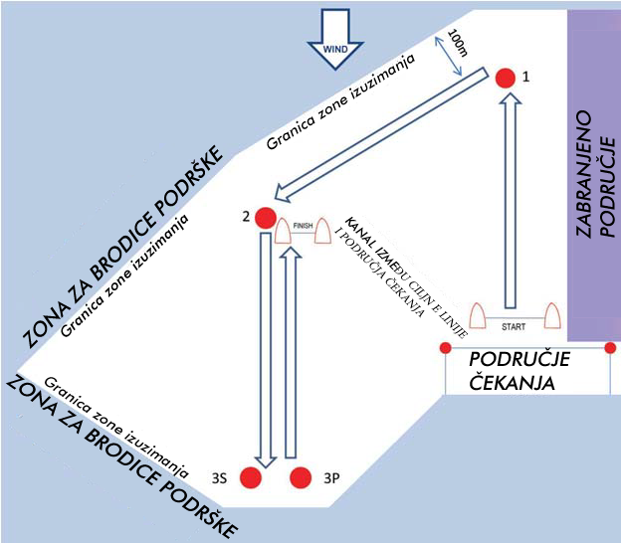

Attachment 2
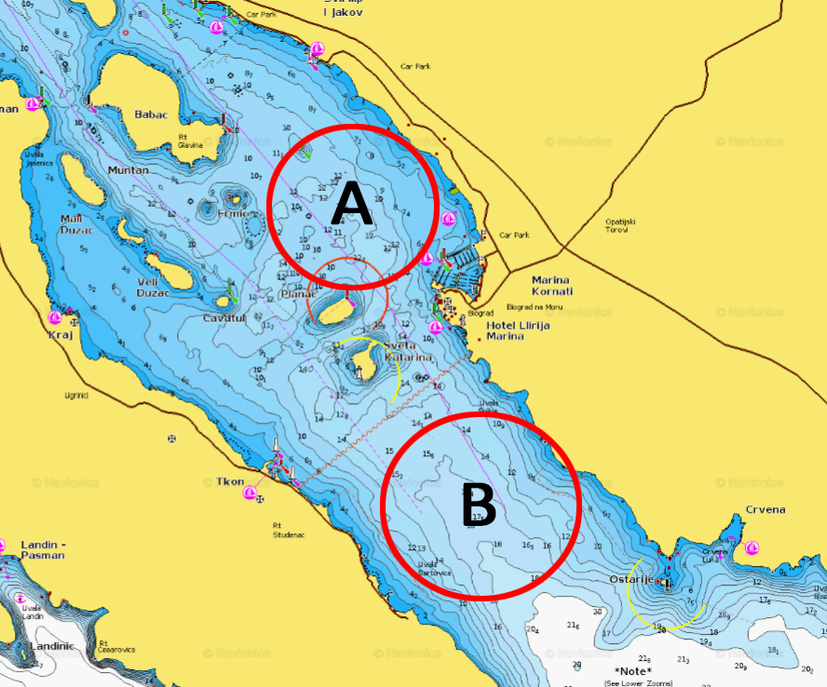

PLAN
